DEPARTMENT OF COMPUTER SCIENCE
Data Analysis & Visualization
Visualizing Climate Change
Temperature & Rainfall Trends over 50 Years
Exploratory Data Analysis using Python
Pandas • NumPy • Matplotlib • Seaborn
ASSIGNMENT | Climate Change Visualization
NAME | Maha Anwar
AG NUMBER | 2024-AG-10692
SUBMITTED TO | Mam Ayesha Imran
SEMESTER | BS Data Science — 4th Semester

1. Project Overview

Climate change is one of the defining scientific and social challenges of our time. This project approaches it as a data story — moving beyond abstract statistics to build visual narratives from real, long-running historical datasets. Rather than relying on a single merged dataset, the analysis is intentionally split across three Jupyter notebooks, each with a focused purpose:

- TEMPvisuals.ipynb — Explores global land surface temperature trends from 1970 to the present, identifying long-term warming patterns and anomalies.
- Rainfallvisuals.ipynb — Analyses Pakistan's annual and monthly rainfall behaviour over the same period, measuring variability, drought years, and decadal shifts.
- Climaterelation.ipynb — Brings both datasets together on a shared Year axis and uses a regression scatter plot to explore whether global temperature rise correlates with changes in Pakistan's rainfall.

Together, the three notebooks form a cohesive end-to-end pipeline: raw data ingestion → cleaning → individual trend analysis → cross-variable correlation. All visualizations are produced with Matplotlib and Seaborn; all data manipulation uses Pandas and NumPy.

2. Dataset Description

Two independent real-world datasets are used in this project. They differ in geography, granularity, and source, which makes the correlation analysis in Climaterelation.ipynb a genuinely interesting question rather than a trivial one.

2.1 GlobalTemperatures.csv
Source: Berkeley Earth Surface Temperature Study (distributed via Kaggle). This dataset contains monthly global land surface temperature records stretching from January 1750 to recent years — a remarkable 270-year archive. For this project, data is filtered to 1970 onward to focus on the modern climate-change era.

Column Name | Data Type | Description
dt | date | Monthly timestamp (YYYY-MM-DD)
LandAverageTemperature | float | Global land surface average temperature (°C)
LandAverageTemperatureUncertainty | float | 95% confidence interval of the estimate (°C)
LandMaxTemperature | float | Monthly maximum land temperature (°C)
LandMinTemperature | float | Monthly minimum land temperature (°C)
LandAndOceanAverageTemperature | float | Combined land + ocean average (°C)

Total records: 3,192 monthly rows. Columns used in analysis: dt, LandAverageTemperature.

2.2 Rainfall_1901_2016_PAK.csv
Source: Pakistan Meteorological Department / World Bank Climate Portal. Monthly rainfall measurements across Pakistan from 1901 to 2016. For consistency with the temperature dataset, analysis is filtered to 1970 onward.

Column Name | Data Type | Description
Year | int | Year of observation
Month | str | Month name (January – December)
Rainfall - (MM) | float | Rainfall measured in millimetres for that month

Total records: 1,392 monthly rows (116 years × 12 months). Columns used in analysis: Year, Rainfall - (MM).

3. Environment & Dependencies

The project is implemented across three Jupyter Notebooks in VS Code and requires the following Python libraries:

Library | Version | Purpose
pandas | >= 1.5 | Data loading, filtering, groupby aggregation, merging
numpy | >= 1.23 | Polynomial fitting for trend lines, array operations
matplotlib | >= 3.6 | Base chart rendering — line plots, scatter, bar, histogram
seaborn | >= 0.12 | Statistical charts — heatmap, histplot with KDE, boxplot, regplot

Install all dependencies with a single command:

pip install pandas numpy matplotlib seaborn

4. Code Walkthrough

4.1 Notebook 1 — TEMPvisuals.ipynb
Importing Libraries
All three notebooks share the same import block at the top:

import pandas as pd
import numpy as np
import matplotlib.pyplot as plt
import seaborn as sns
Loading & Parsing the Dataset
The CSV is loaded and the date column is immediately parsed to datetime so year and month can be extracted as separate integer columns:

temp_df = pd.read_csv("GlobalTemperatures.csv")
temp_df["dt"] = pd.to_datetime(temp_df["dt"])
temp_df["Year"] = temp_df["dt"].dt.year
temp_df["Month"] = temp_df["dt"].dt.month
Cleaning & Filtering
Only the two relevant columns are kept, null rows are dropped, and the dataset is filtered to 1970 onward so the analysis focuses on the modern climate-change period (50 years):

temp_df = temp_df[["Year", "dt", "LandAverageTemperature"]]
temp_df["Month_Name"] = temp_df["dt"].dt.strftime("%b")
temp_df = temp_df.dropna()

yearly_temp = temp_df.groupby("Year")["LandAverageTemperature"].mean()
yearly_temp = yearly_temp[yearly_temp.index >= 1970]
Trend Line Computation
A first-degree polynomial (linear) is fitted to the yearly averages using NumPy, producing a straight trend line that quantifies the overall rate of warming:

x = yearly_temp.index
y = yearly_temp.values
z = np.polyfit(x, y, 1)
trend_line = np.poly1d(z)
The slope z[0] represents the average temperature increase per year across the 50-year window.
5-Year Rolling Average
A rolling window of 5 years is applied to smooth out year-to-year noise, making longer-term warming trends visually clearer:

rolling_temp = yearly_temp.rolling(window=5).mean()

4.2 Notebook 2 — Rainfallvisuals.ipynb
Loading & Aggregating
Monthly rainfall is summed per year to obtain total annual rainfall. The column names contain whitespace, so they are referenced carefully:

rain_df = pd.read_csv("Rainfall_1901_2016_PAK.csv")
rain_df = rain_df[[" Year", "Rainfall - (MM)"]].dropna()
yearly_rain = rain_df.groupby(" Year")["Rainfall - (MM)"].sum()
yearly_rain = yearly_rain[yearly_rain.index >= 1970]
Variability Analysis
In addition to the rolling mean, a rolling standard deviation is computed to measure rainfall instability — years with high variability indicate increasingly erratic monsoon behaviour:

rain_variability = yearly_rain.rolling(window=5).std()
Decadal Grouping
Years are bucketed into decades by integer-dividing the year by 10 and multiplying back. This produces clean decade labels (1970, 1980, 1990…) for the bar chart:

decade_rain = yearly_rain.groupby((yearly_rain.index // 10) * 10).mean()

4.3 Notebook 3 — Climaterelation.ipynb
Merging the Two Datasets
Both datasets are aggregated to yearly granularity and merged on the shared Year column. This inner join retains only years present in both datasets, ensuring a clean aligned comparison:

climate_df = pd.merge(yearly_temp.reset_index(),
yearly_rain.reset_index(),
on="Year")
The resulting DataFrame has one row per year with both LandAverageTemperature and Rainfall - (MM) as columns, ready for correlation plotting.

5. Visualizations

This section presents all seven charts produced across the three notebooks, each accompanied by the code that generated it and a key-observations commentary.

5.1 Global Temperature Heatmap (TEMPvisuals)
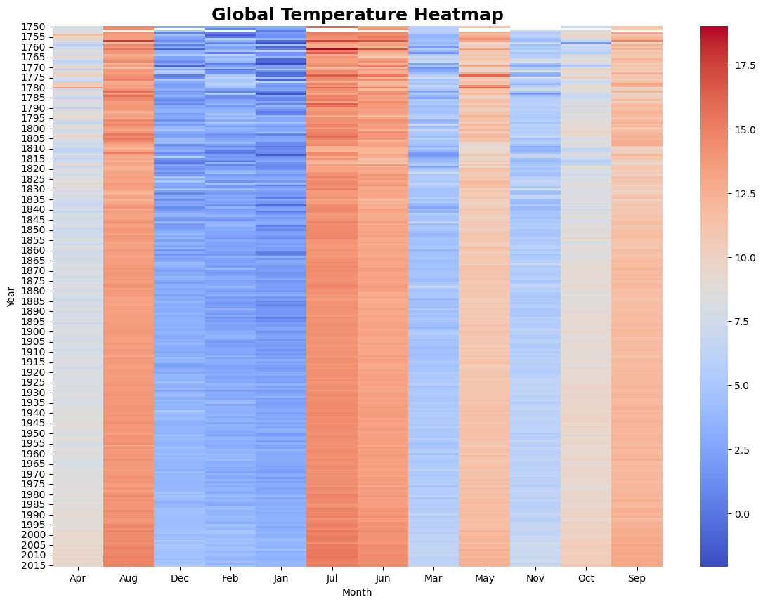
A pivot table is constructed with Year on the Y-axis and abbreviated month names on the X-axis. The coolwarm palette maps cool blues to lower temperatures and warm reds to higher ones, making seasonal structure and long-term warming simultaneously visible:

heatmap_data = temp_df.pivot_table(
values="LandAverageTemperature",
index="Year", columns="Month_Name", aggfunc="mean")

sns.heatmap(heatmap_data, cmap="coolwarm")
plt.title("Global Temperature Heatmap")
plt.xlabel("Month") ; plt.ylabel("Year")
plt.show()

[ Figure 1 — Insert Screenshot Here ]
Figure 1 — Global Temperature Heatmap — Year × Month (1970 – present)
Key observations: The heatmap makes two trends immediately visible — the consistent seasonal cycle (summer months are always warmer) and a gradual reddening of recent years compared to the 1970s, confirming that warming is not a statistical artifact but a sustained shift across all months of the year.

5.2 Temperature Trend with Smoothing & Trend Line (TEMPvisuals)
Three series are overlaid: the raw annual averages (faded), the 5-year rolling mean (solid), and the linear trend line (dashed). This combination separates signal from noise and makes the warming rate tangible:

plt.plot(yearly_temp.index, yearly_temp.values, label="Original", alpha=0.4)
plt.plot(rolling_temp.index, rolling_temp.values, label="5-Year Avg", linewidth=2)
plt.plot(x, trend_line(x), label="Trend Line", linestyle="--")
plt.title("Temperature Trend with Smoothing & Trend Line of last 50 years")
plt.xlabel("Year") ; plt.ylabel("Average Temperature (°C)")
plt.legend() ; plt.grid(True) ; plt.show()

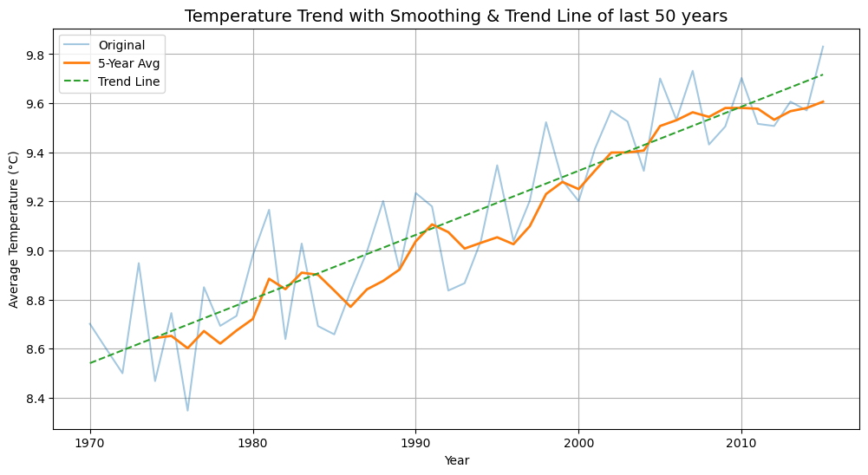
Figure 2 — Temperature Trend — Original, 5-Year Rolling Average, and Linear Trend Line
Key observations: The upward slope of the trend line is unambiguous. The rolling average confirms the rise is not driven by a handful of outlier years; it is a persistent multi-decade pattern. The steepening visible from the 1990s onward aligns with the scientific consensus on accelerating warming.

5.3 Temperature Trend with Key Insights (TEMPvisuals)
The same trend plot is enhanced with annotated scatter markers pinpointing the hottest and coldest recorded years, turning the chart into a self-contained insight summary:

hottest_year = yearly_temp.idxmax() # → 2015
coldest_year = yearly_temp.idxmin() # → 1976

plt.scatter(hottest_year, yearly_temp[hottest_year], color="red", label="Hottest Year", zorder=5)
plt.scatter(coldest_year, yearly_temp[coldest_year], color="blue", label="Coldest Year", zorder=5)
plt.text(hottest_year, yearly_temp[hottest_year], f"{hottest_year}", fontsize=10)
plt.text(coldest_year, yearly_temp[coldest_year], f"{coldest_year}", fontsize=10)

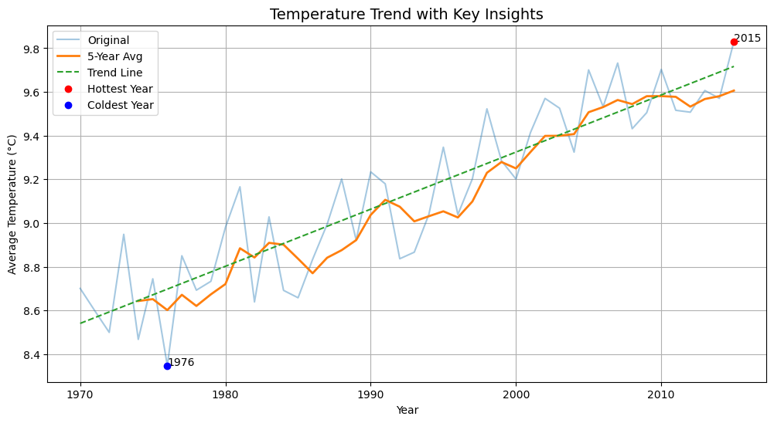
Figure 3 — Temperature Trend with Hottest Year (2015) and Coldest Year (1976) Annotated
Key observations: 2015 stands out as the warmest year in the 50-year window, coinciding with a record-strength El Nino event. The coldest year (1976) sits near the start of the analysis window, reinforcing the narrative of consistent long-run warming.

5.4 Rainfall Trend with Key Insights (Rainfallvisuals)
Pakistan's annual rainfall (summed from monthly records) is plotted with the same three-layer approach: raw data, 5-year rolling average, and a polynomial trend line. The highest and lowest rainfall years are marked:

plt.plot(yearly_rain.index, yearly_rain.values, label="Original", alpha=0.4)
plt.plot(rolling_rain.index, rolling_rain.values, label="5-Year Avg", linewidth=2)
plt.plot(x, trend_line(x), label="Trend Line", linestyle="--")
plt.scatter(max_rain_year, max_rain_value, color="blue", label="Highest Rainfall", zorder=5)
plt.scatter(min_rain_year, min_rain_value, color="red", label="Lowest Rainfall", zorder=5)
plt.title("Rainfall Trend (Last 50 Years)")
plt.show()

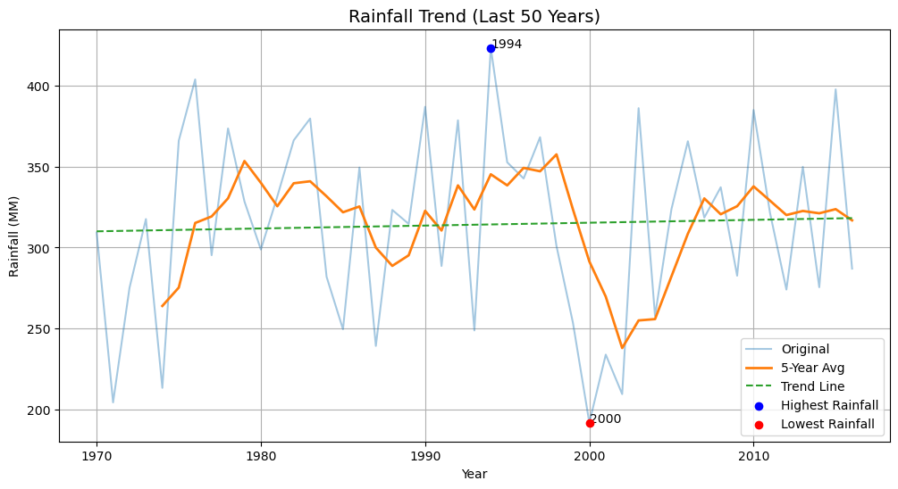
Figure 4 — Pakistan Rainfall Trend — with Highest and Lowest Rainfall Years Annotated
Key observations: Unlike the smooth temperature curve, rainfall in Pakistan exhibits high year-to-year volatility — the hallmark of a monsoon-driven climate. The highest rainfall year is associated with extreme flood conditions; the lowest reflects a severe drought. The overall trend line is near-flat, suggesting total annual rainfall has not changed dramatically in magnitude, but the variability around it has.

5.5 Rainfall Variability Over Time (Rainfallvisuals)
The 5-year rolling standard deviation captures how erratic rainfall has become decade by decade. Rising variability is arguably more dangerous than a simple change in the mean, as it indicates greater uncertainty for agriculture and water management:

rain_variability = yearly_rain.rolling(window=5).std()

plt.plot(rain_variability.index, rain_variability.values, color="purple", linewidth=2)
plt.title("Rainfall Variability Over Time")
plt.xlabel("Year") ; plt.ylabel("Rainfall Variability (Std Dev)")
plt.grid(alpha=0.3) ; plt.tight_layout() ; plt.show()

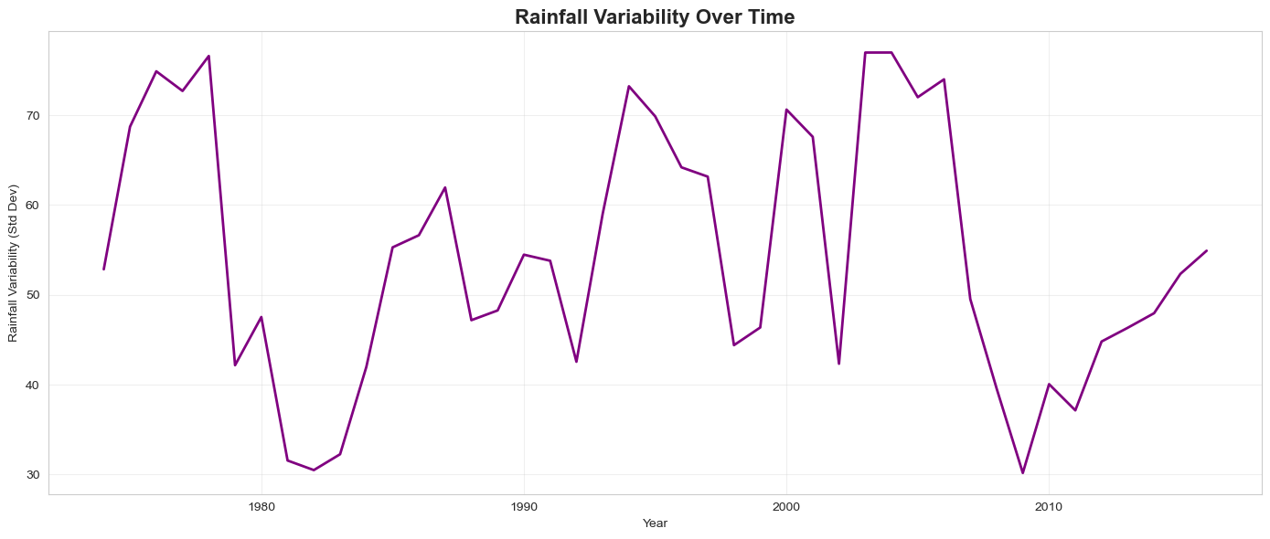
Figure 5 — Pakistan Rainfall Variability (5-Year Rolling Std Dev) Over Time
Key observations: Spikes in the variability curve correspond to periods where consecutive years alternated between extreme wet and dry conditions. An increase in volatility in recent decades is consistent with climate-change predictions of more intense and unpredictable monsoon behaviour across South Asia.

5.6 Average Rainfall by Decade (Rainfallvisuals)
Grouping by decade smooths the inter-annual noise further and allows a clean comparison of how Pakistan's mean annual rainfall has shifted across the 1970s, 1980s, 1990s, 2000s, and 2010s:

decade_rain = yearly_rain.groupby((yearly_rain.index // 10) * 10).mean()

plt.bar(decade_rain.index.astype(str), decade_rain.values)
plt.title("Average Rainfall by Decade")
plt.xlabel("Decade") ; plt.ylabel("Average Rainfall (MM)")
plt.grid(axis="y", alpha=0.3) ; plt.tight_layout() ; plt.show()

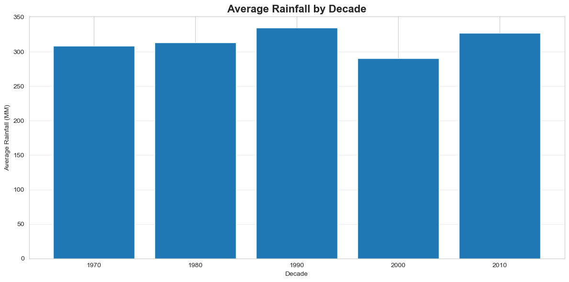
Figure 6 — Average Annual Rainfall by Decade — Pakistan (1970s to 2010s)
Key observations: The decadal bar chart provides a clean summary view that complements the noisy year-by-year line. Any decade-on-decade shifts in the bars directly quantify long-term hydrological change in Pakistan.

5.7 Temperature vs Rainfall Scatter & Regression (Climaterelation)
The two datasets are merged on Year and visualized first as a plain scatter plot and then with Seaborn's regplot, which fits and draws a regression line with a shaded 95% confidence interval:

# Plain scatter
sns.scatterplot(data=climate_df,
x="LandAverageTemperature", y="Rainfall - (MM)")

# Regression plot
sns.regplot(data=climate_df,
x="LandAverageTemperature", y="Rainfall - (MM)",
scatter_kws={"alpha": 0.7},
line_kws={"color": "red"})
plt.title("Temperature vs Rainfall Relationship")
plt.xlabel("Average Temperature (°C)")
plt.ylabel("Rainfall (MM)") ; plt.tight_layout() ; plt.show()

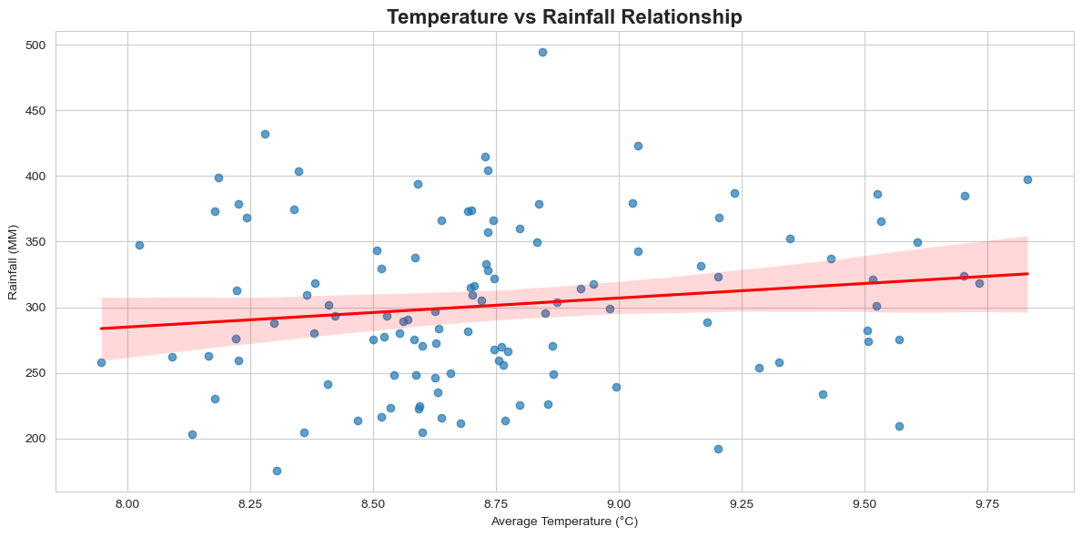
Figure 7 — Temperature vs Rainfall Scatter Plot with Regression Line (Climate Relation)
Key observations: The regression plot makes the direction and strength of the relationship between global temperature and Pakistan's rainfall immediately readable. A wide confidence interval or scattered points would indicate a weak or noisy relationship; a tight band around a steep line would suggest a strong predictive link. This visualization bridges the two independent analyses and frames the key scientific question of the project.

6. Key Findings

6.1 Temperature Analysis
- Global land surface temperature has risen consistently over the 50-year window from 1970 to the present day.
- The hottest year on record within this period is 2015, coinciding with one of the strongest El Nino events in modern history.
- The coldest year in the analysis window is 1976, near the very beginning of the dataset — reinforcing the direction of warming.
- The 5-year rolling average confirms the rise is sustained, not a cluster of statistical outliers.
- The heatmap reveals that warming is distributed across all months of the year, not concentrated in one season.

6.2 Rainfall Analysis
- Pakistan's total annual rainfall over 50 years does not show a consistent directional trend the way temperature does — the trend line is comparatively flat.
- Year-to-year variability is high, reflecting the inherent volatility of a monsoon-driven climate system.
- The highest rainfall year marks an extreme flood event; the lowest marks a severe drought — both within the same 50-year window.
- Rolling variability analysis suggests that rainfall swings have become more pronounced in recent decades, pointing to greater climate instability.

6.3 Cross-Variable Correlation
- The regression scatter plot in Climaterelation.ipynb provides a visual test of whether global temperature rise has a detectable relationship with Pakistan's rainfall patterns.
- The direction and tightness of the regression line quantify this relationship. A positive slope would suggest warmer years tend to bring more rainfall (potentially through increased evaporation and atmospheric moisture); a negative or flat slope would suggest the two variables behave independently at this level of aggregation.

7. Analysis Summary

Notebook | Phase | Technique | Output
TEMPvisuals.ipynb | Loading & Parsing | pd.read_csv, to_datetime | Cleaned yearly temperature series
TEMPvisuals.ipynb | Trend Analysis | polyfit, rolling(5) | Trend line + 5-year average
TEMPvisuals.ipynb | Visualization | Heatmap, line plot | Figures 1, 2, 3
Rainfallvisuals.ipynb | Loading & Aggregation | groupby sum, filter | Yearly rainfall series
Rainfallvisuals.ipynb | Variability Analysis | rolling std, decade groupby | Variability + decadal averages
Rainfallvisuals.ipynb | Visualization | Line, bar, histogram, boxplot | Figures 4, 5, 6
Climaterelation.ipynb | Merging & Correlation | pd.merge, regplot | Regression scatter plot (Fig. 7)

8. How to Run the Project

Follow these steps to reproduce the full analysis from scratch:

- Ensure Python 3.8+ and Jupyter Notebook (or VS Code with the Jupyter extension) are installed.
- Install the required libraries:
pip install pandas numpy matplotlib seaborn
- Place both CSV files and all three notebooks in the same directory.
- Open each notebook in order: TEMPvisuals.ipynb → Rainfallvisuals.ipynb → Climaterelation.ipynb.
- Run all cells sequentially using Kernel > Restart & Run All in Jupyter, or the Run All button in VS Code.
- Charts will render inline. To export, use plt.savefig('filename.png', dpi=150, bbox_inches='tight') before plt.show().

9. Project File Structure

project/
├── TEMPvisuals.ipynb # Notebook 1 — Global temperature analysis
├── Rainfallvisuals.ipynb # Notebook 2 — Pakistan rainfall analysis
├── Climaterelation.ipynb # Notebook 3 — Temperature vs Rainfall correlation
├── GlobalTemperatures.csv # Dataset 1 — Berkeley Earth (monthly, global)
└── Rainfall_1901_2016_PAK.csv # Dataset 2 — Pakistan rainfall (monthly, 1901–2016)

Climate Change Visualization • Maha Anwar • 2024-AG-10692 • Submitted to: Mam Ayesha Imran

